**EXPERIMENT-6**

**NAME:** SHAIKH MUBASHIRA TUFEL AHMED

**ROLL NO:** 612055 **COURSE:** ADVANCE DEVOPS(ITL504)

**BRANCH:** T.E. INFORMATION TECHNOLOGY (SEM 5)

1. **To create a Lambda function which will log “An Image has been added” once you add an object to a specific bucket in S3. Use AWS Lambda blueprint.**

**Step 1: AWS Management Console Dashboard.**

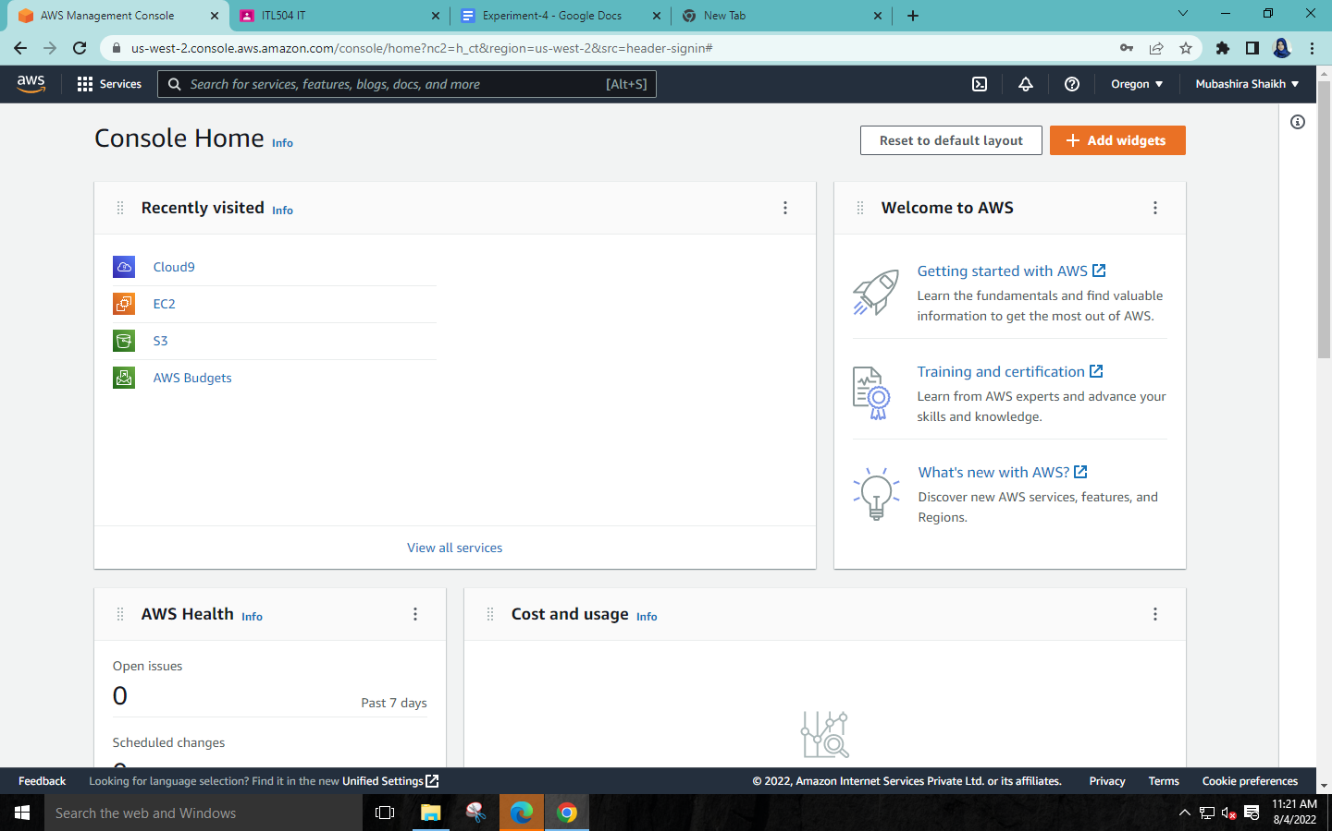

**Step 2:Click on Servises→Storage→S3**

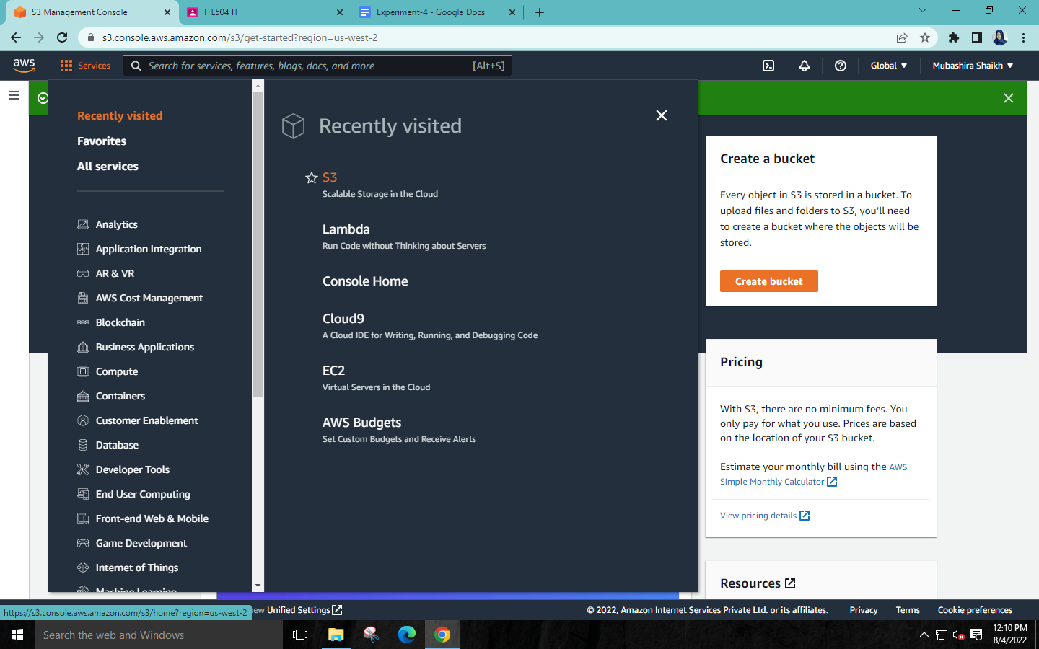

**Step 3:Click on ‘Create bucket’**



**Step 4:Give your bucket a name🡪Click on Create bucket.**

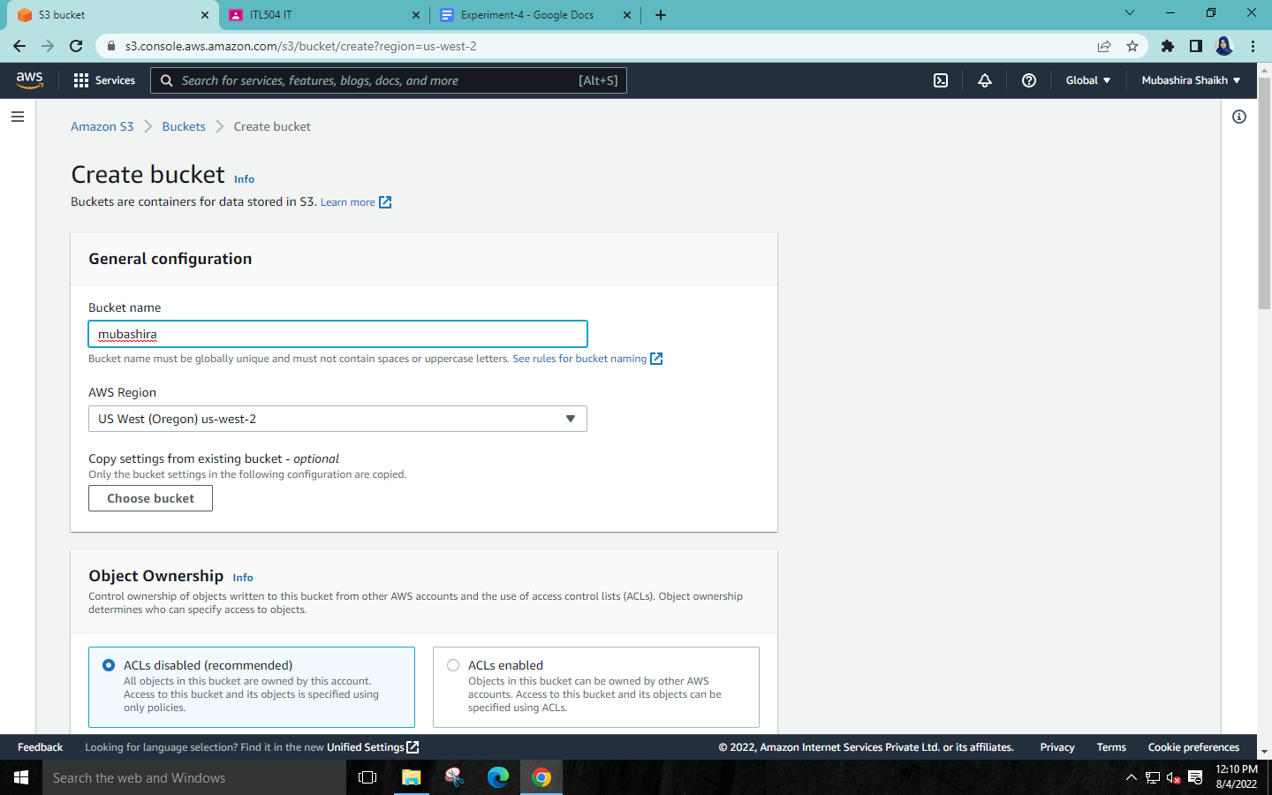

**Step 5: Search for DynamoDB and select it.**

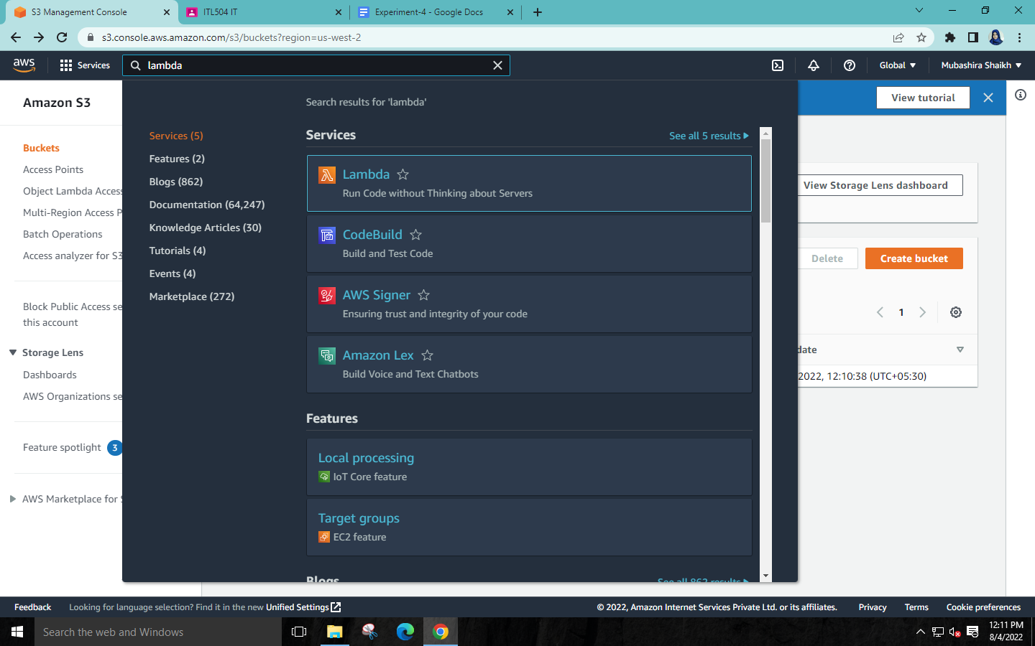

**Step 6: Click on Create Function.**

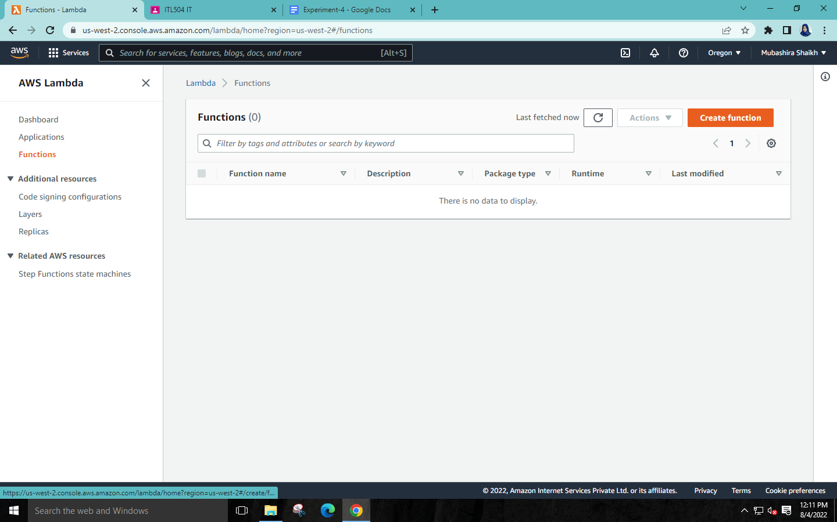

**Step 7:Choose “Use a blueprint”🡪Search s3 in “Blueprints”🡪Select “s3-get-object-python”**

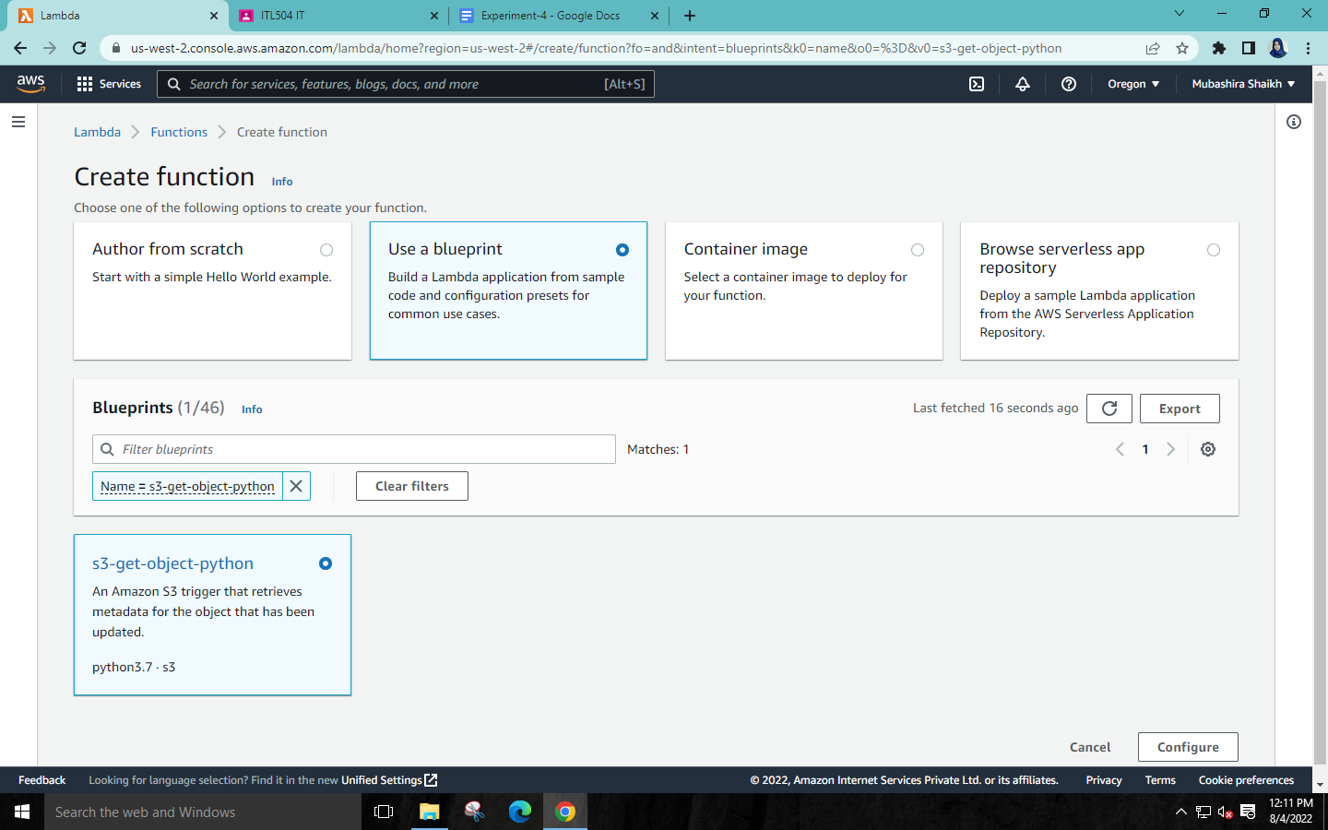

**Step 8: Name the Function & Role🡪Select your S3 bucket as trigger 🡪Click on Create Function.**

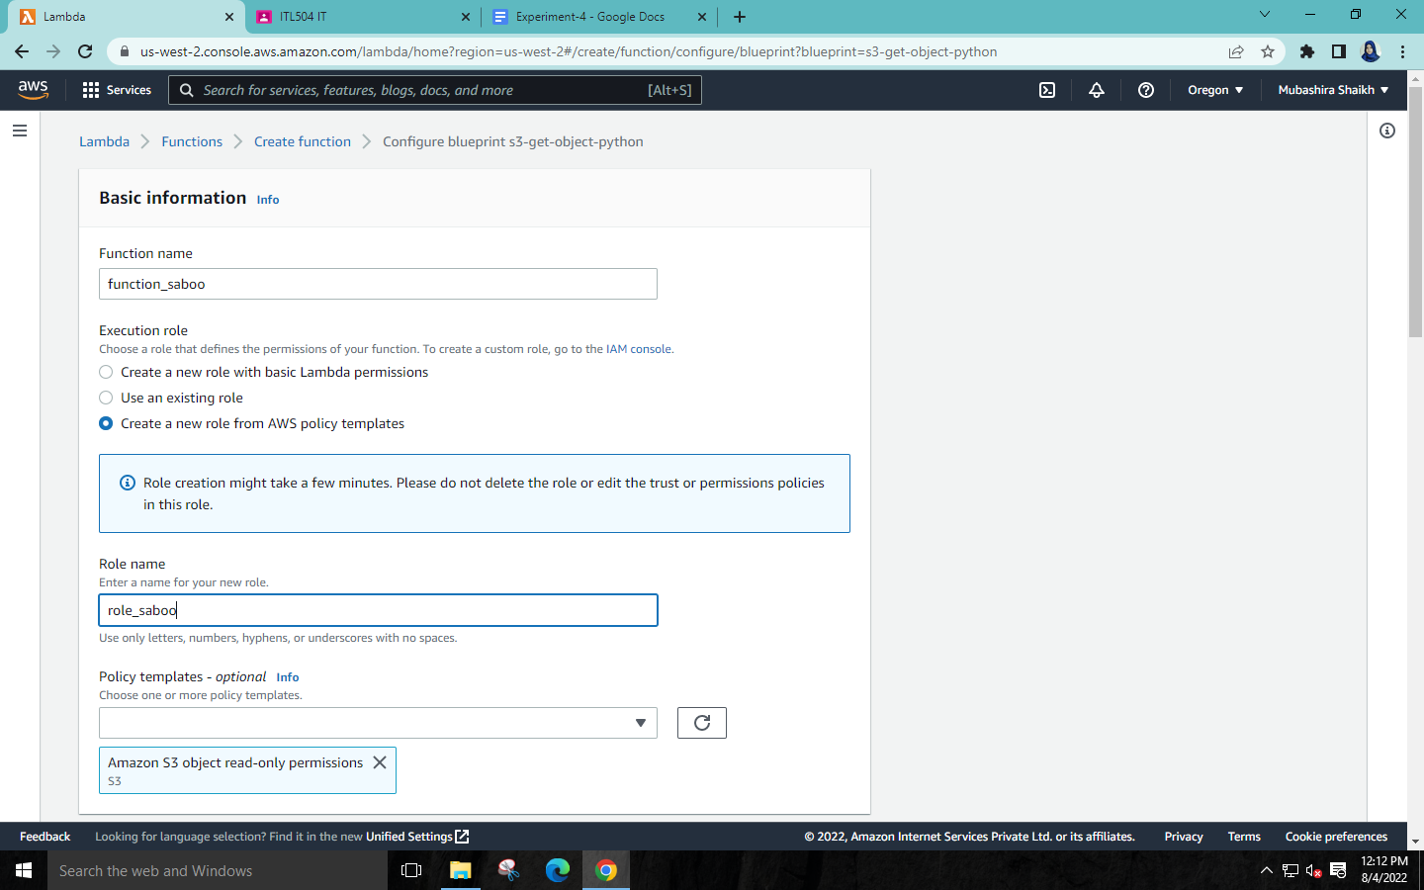

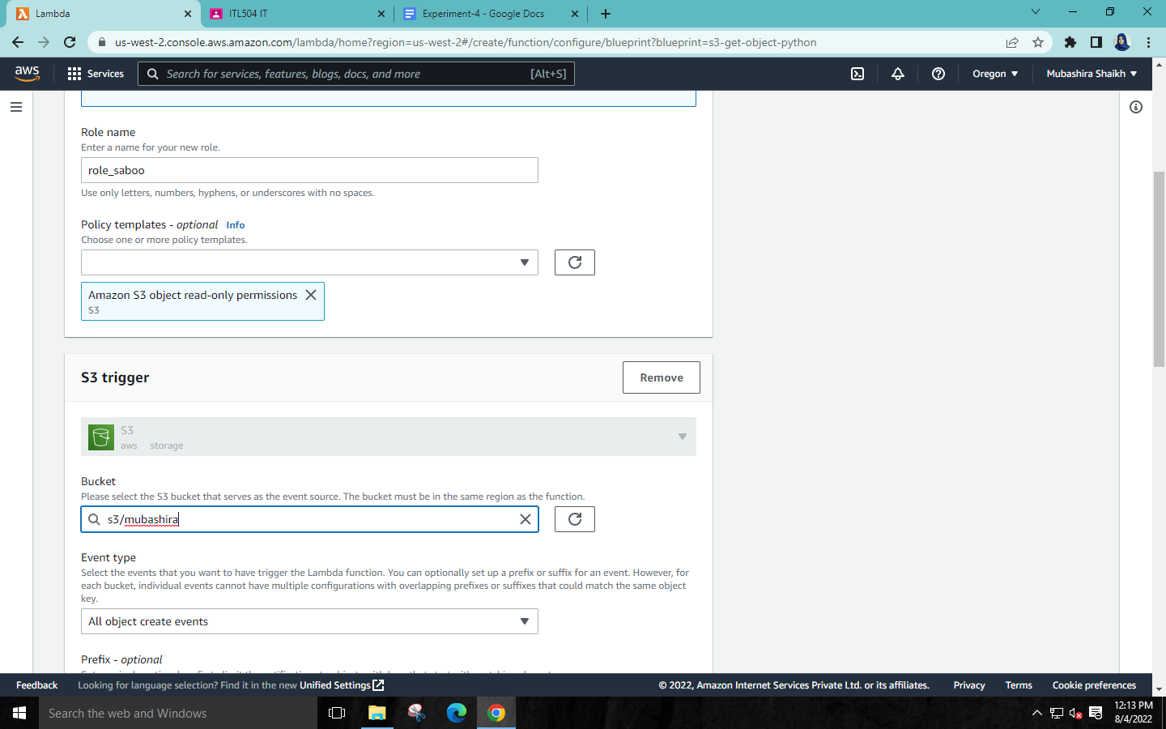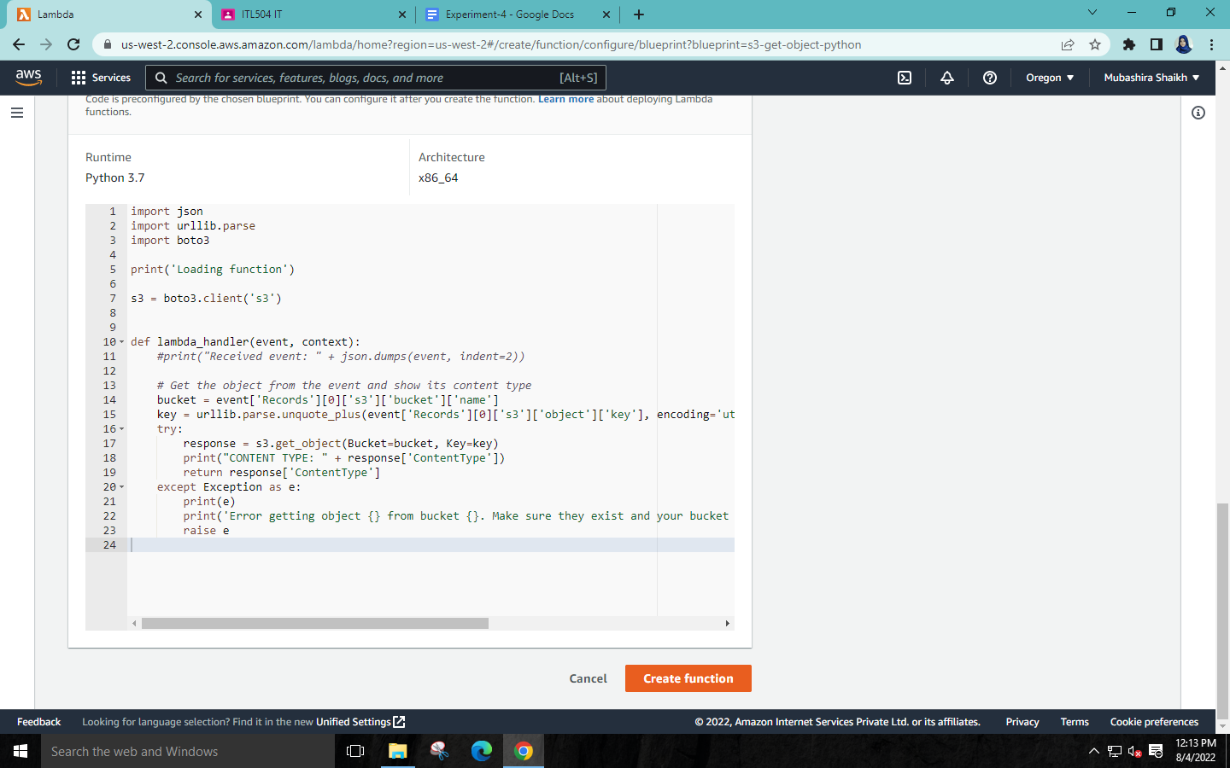

**Step 9:Click on your function🡪Go to code🡪Add a print statement in code🡪Save the code and deploy it.**

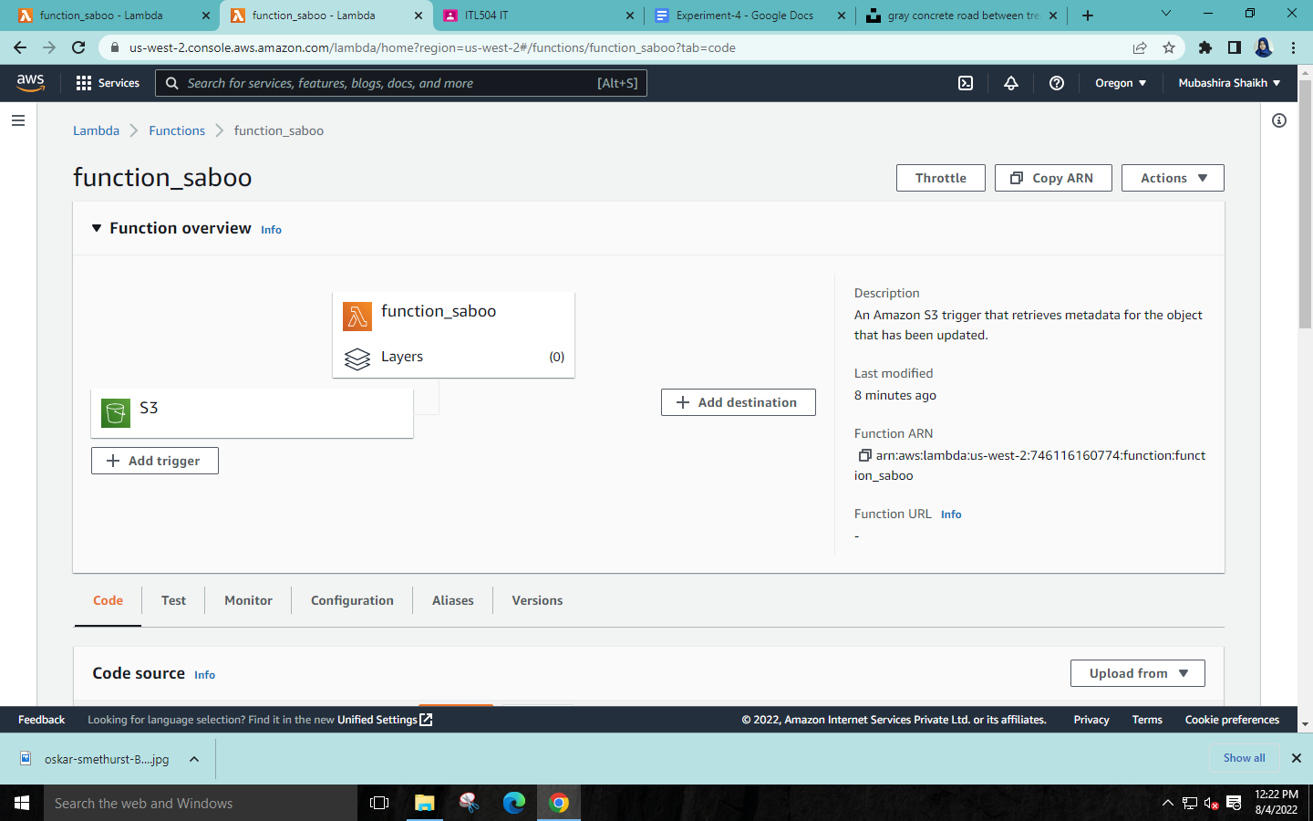

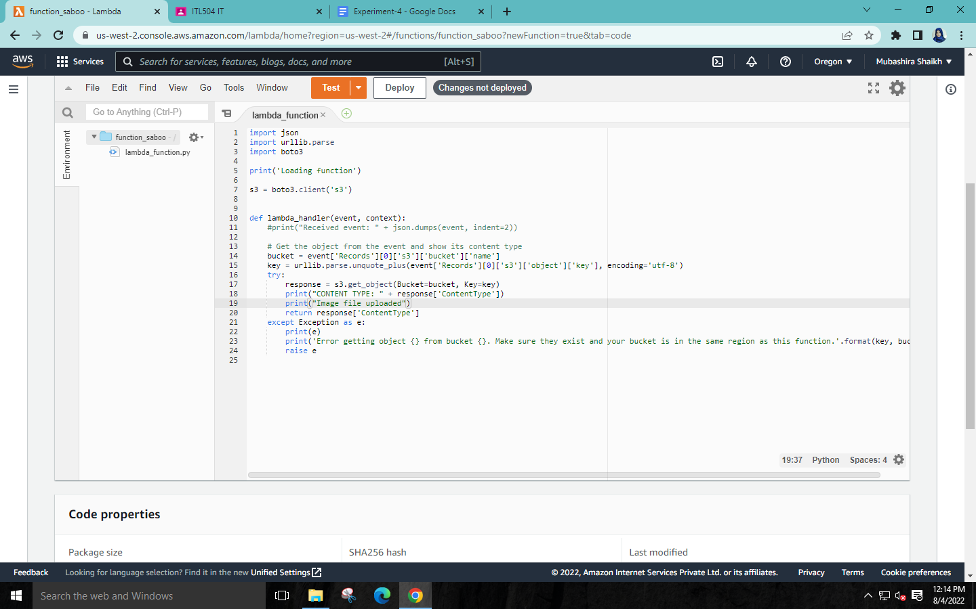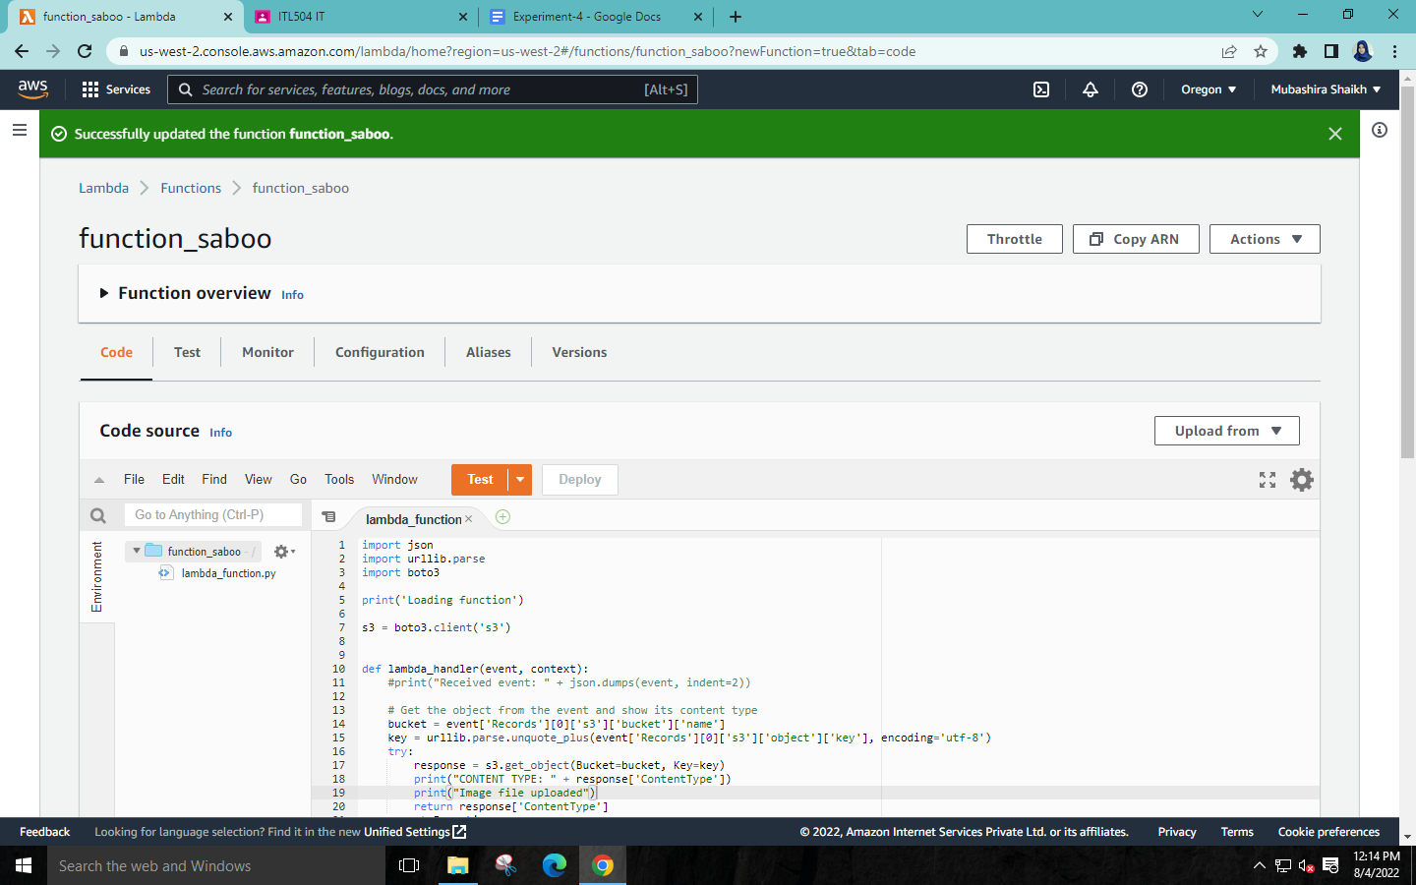

**Step 10: Go to your bucket 🡪Upload an image as object in your bucket🡪Click on upload.**

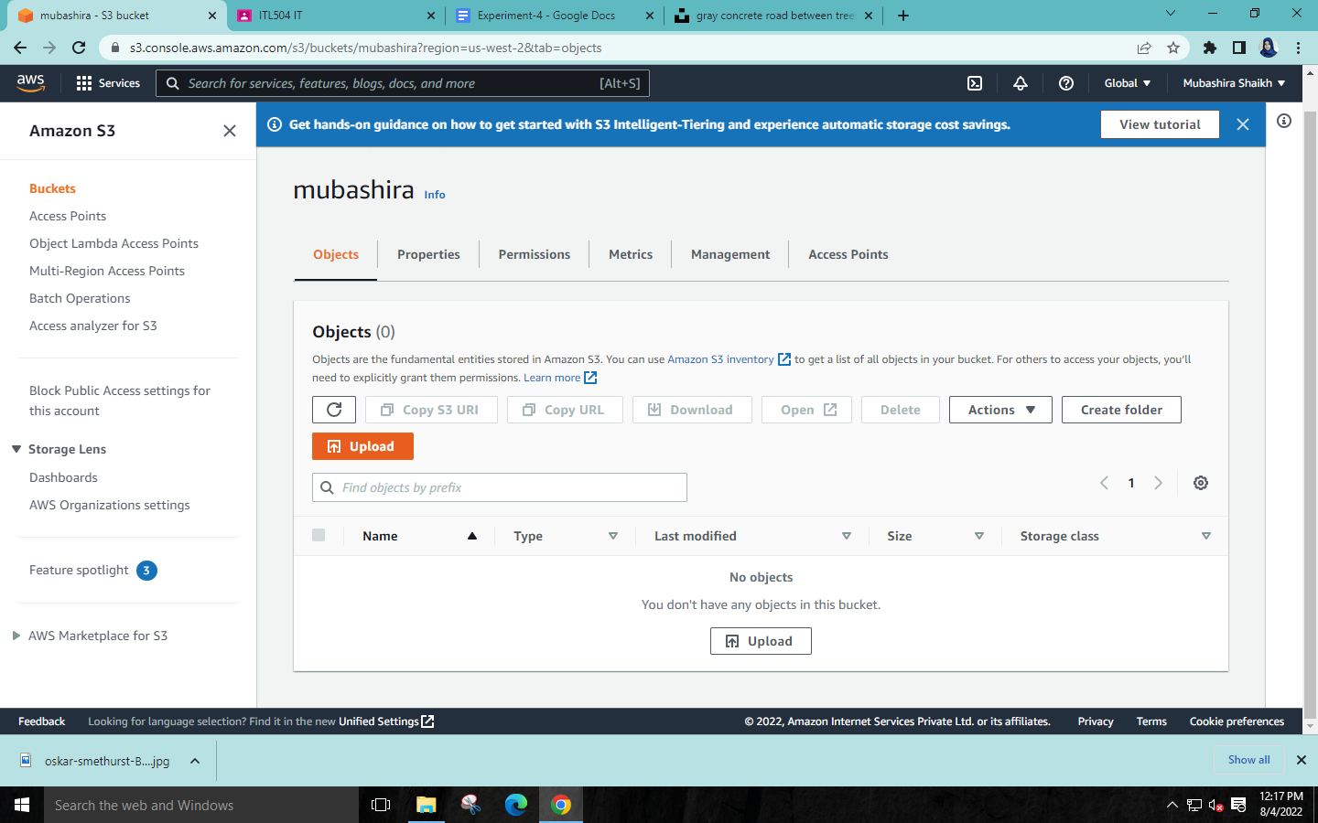

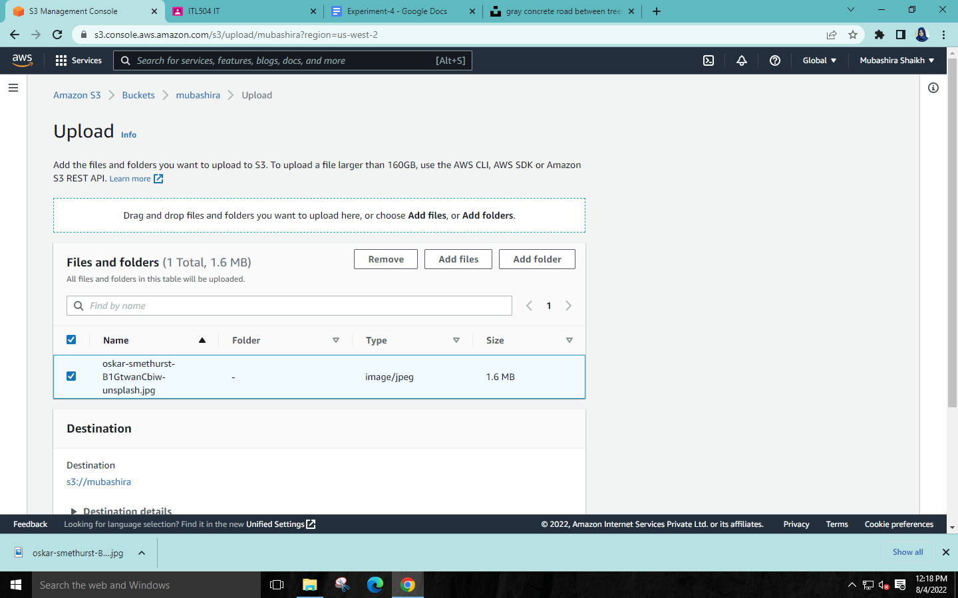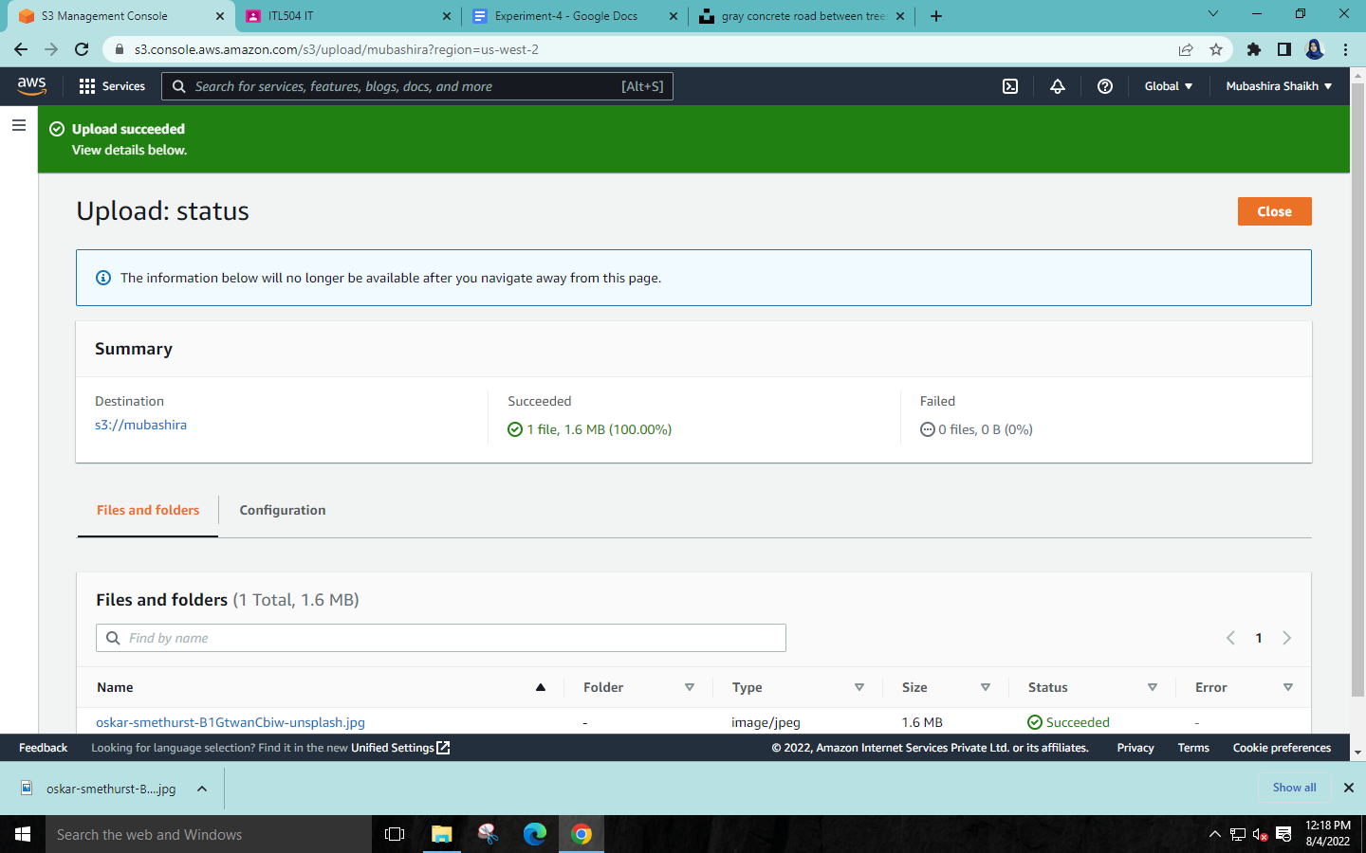

**Step 11: Click on your lambda function🡪Monitor🡪View logs in CloudWatch.**

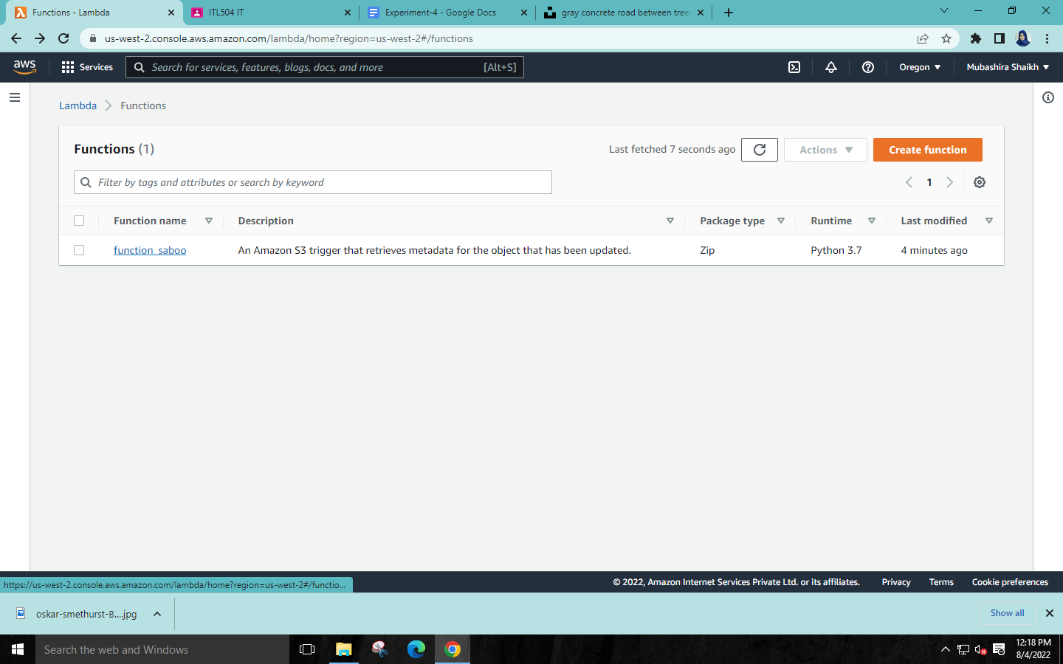

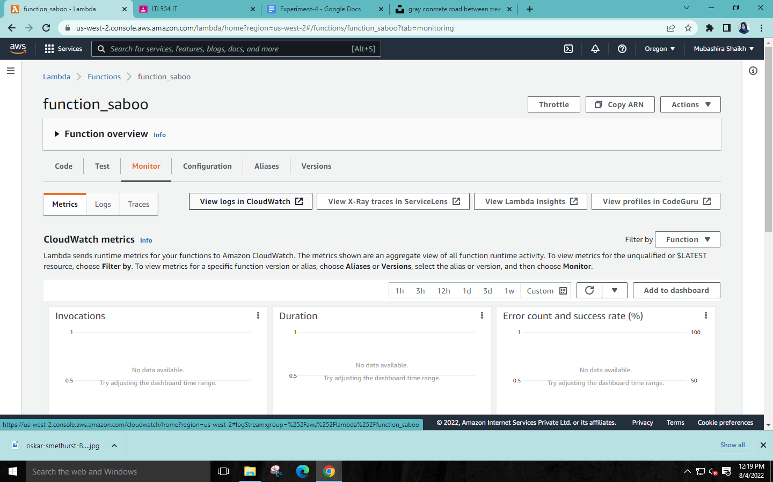

**Step 12: Click the blue link in Log stream🡪Check the message “Image file uploaded”** 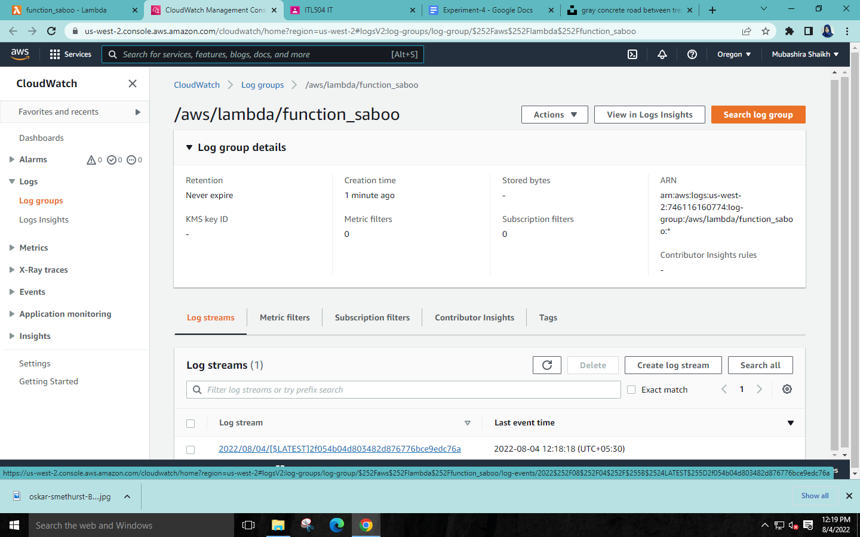

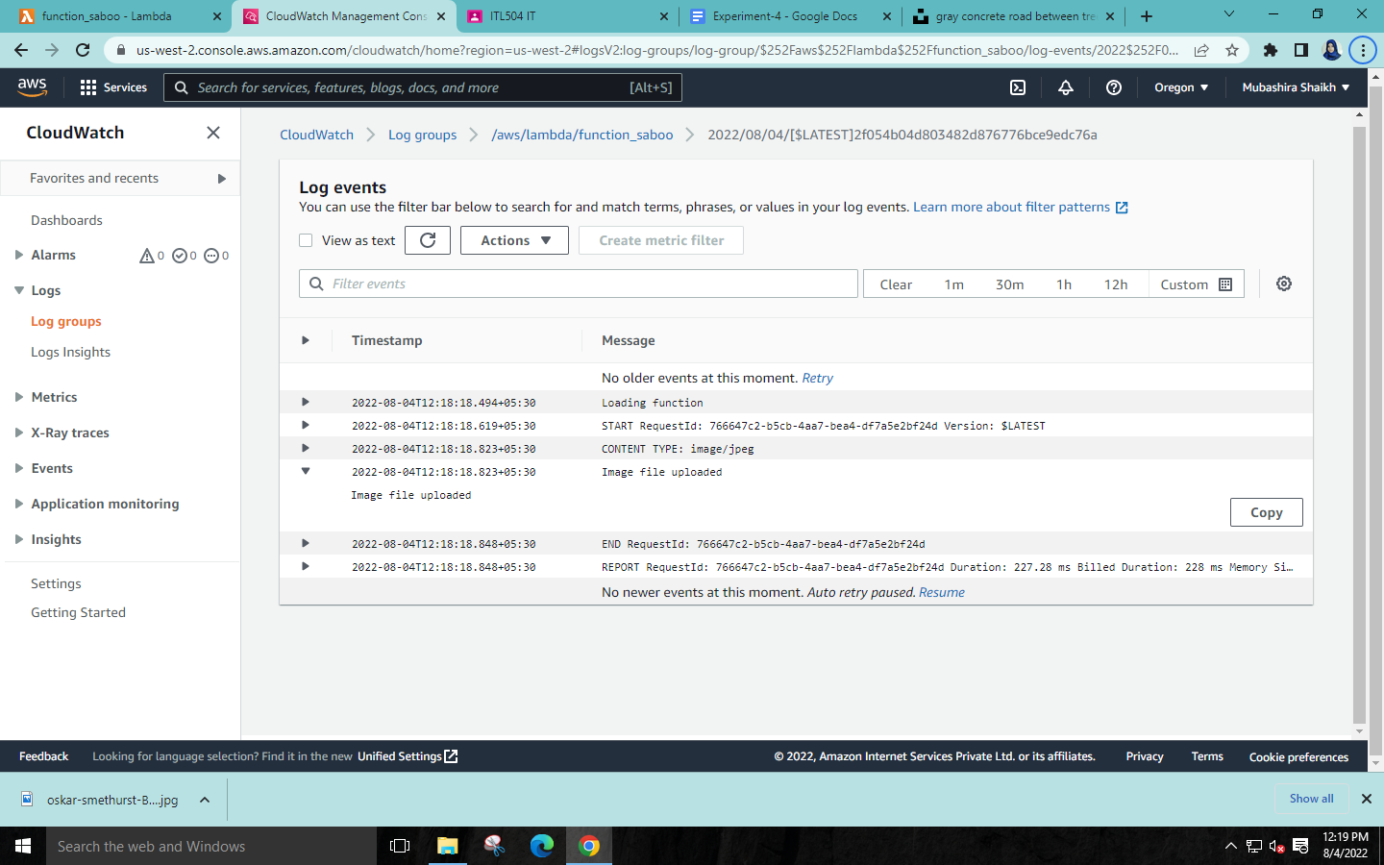

**Step 13:Delete your lambda function**

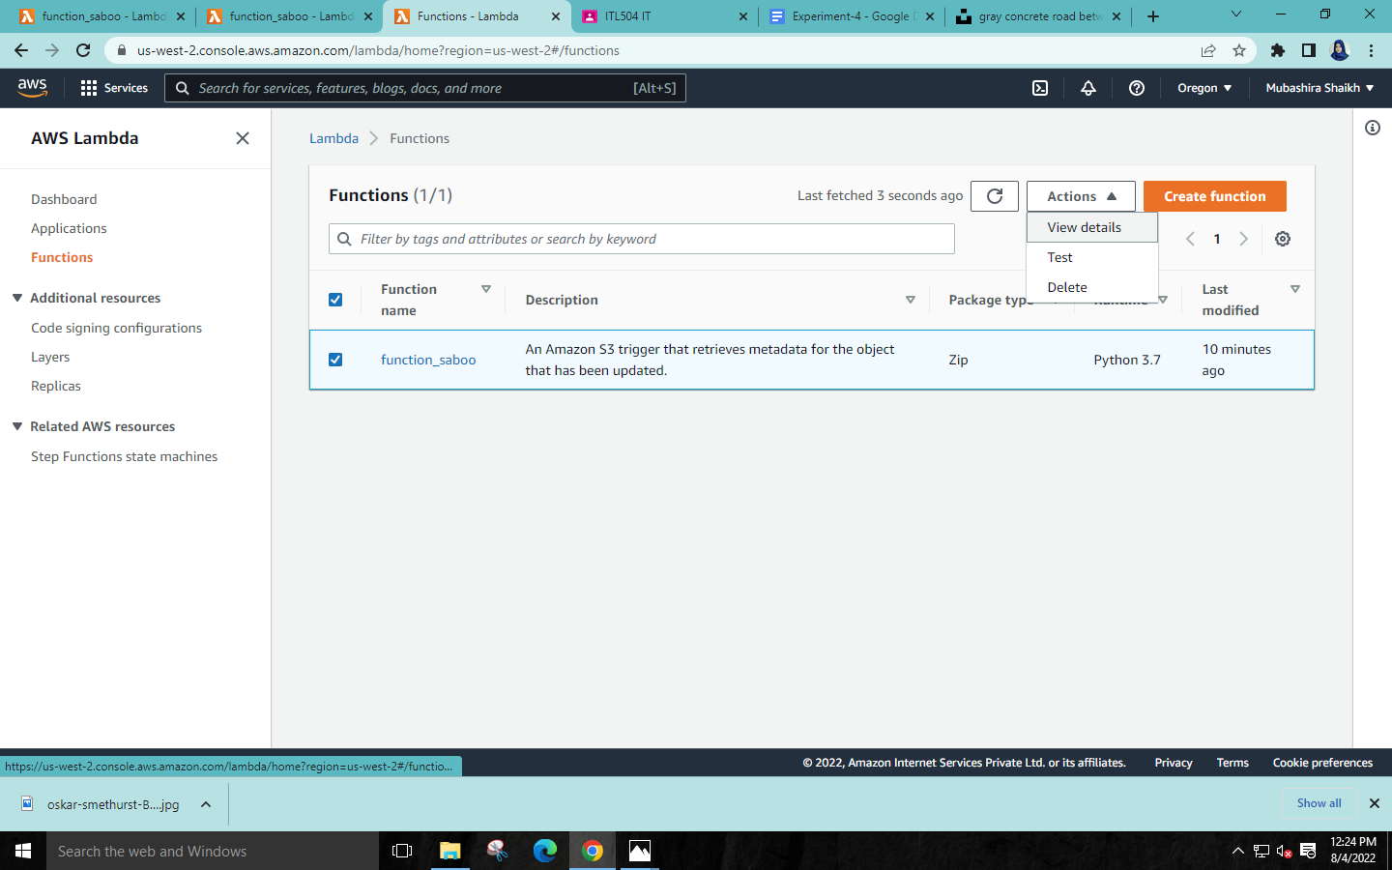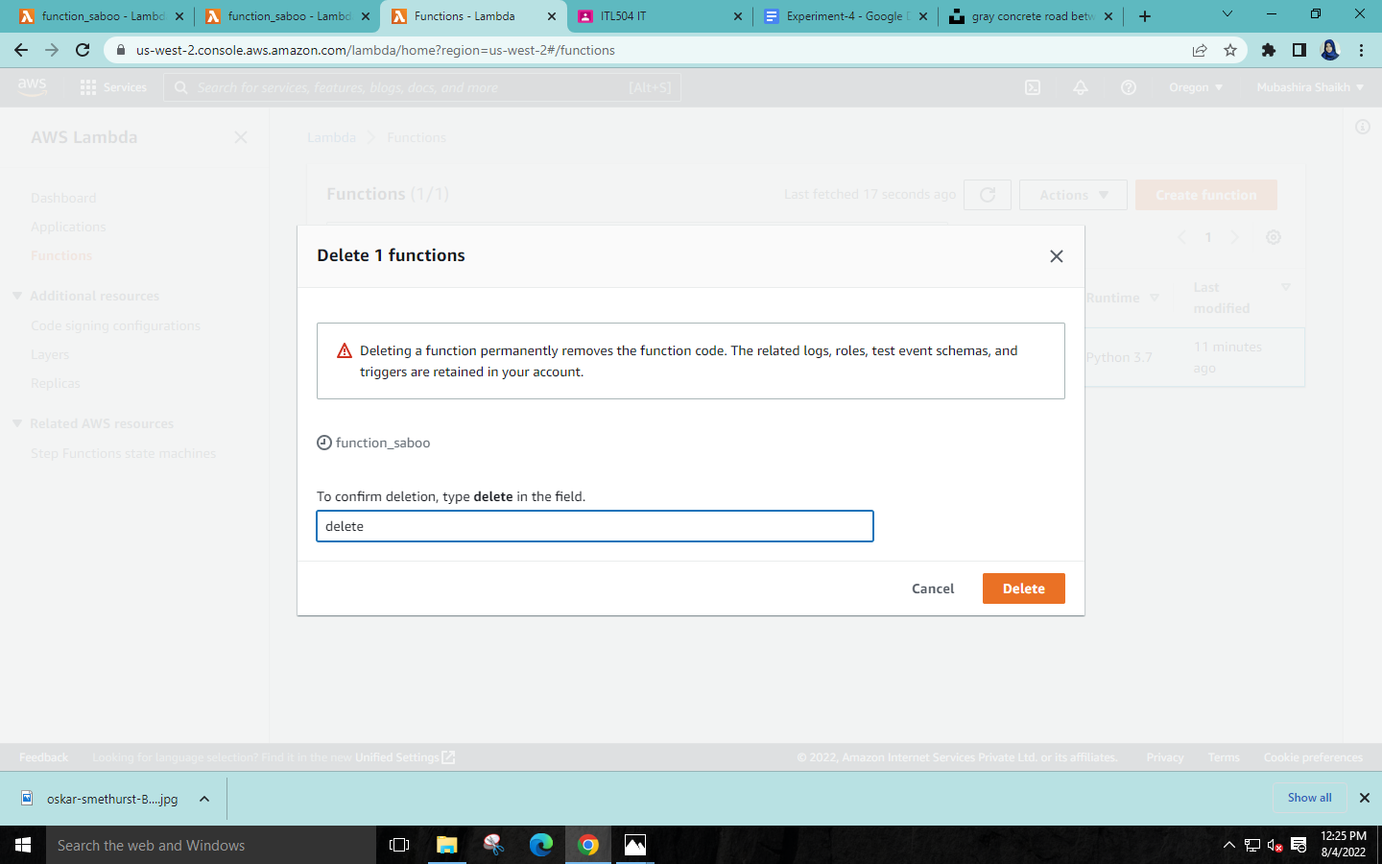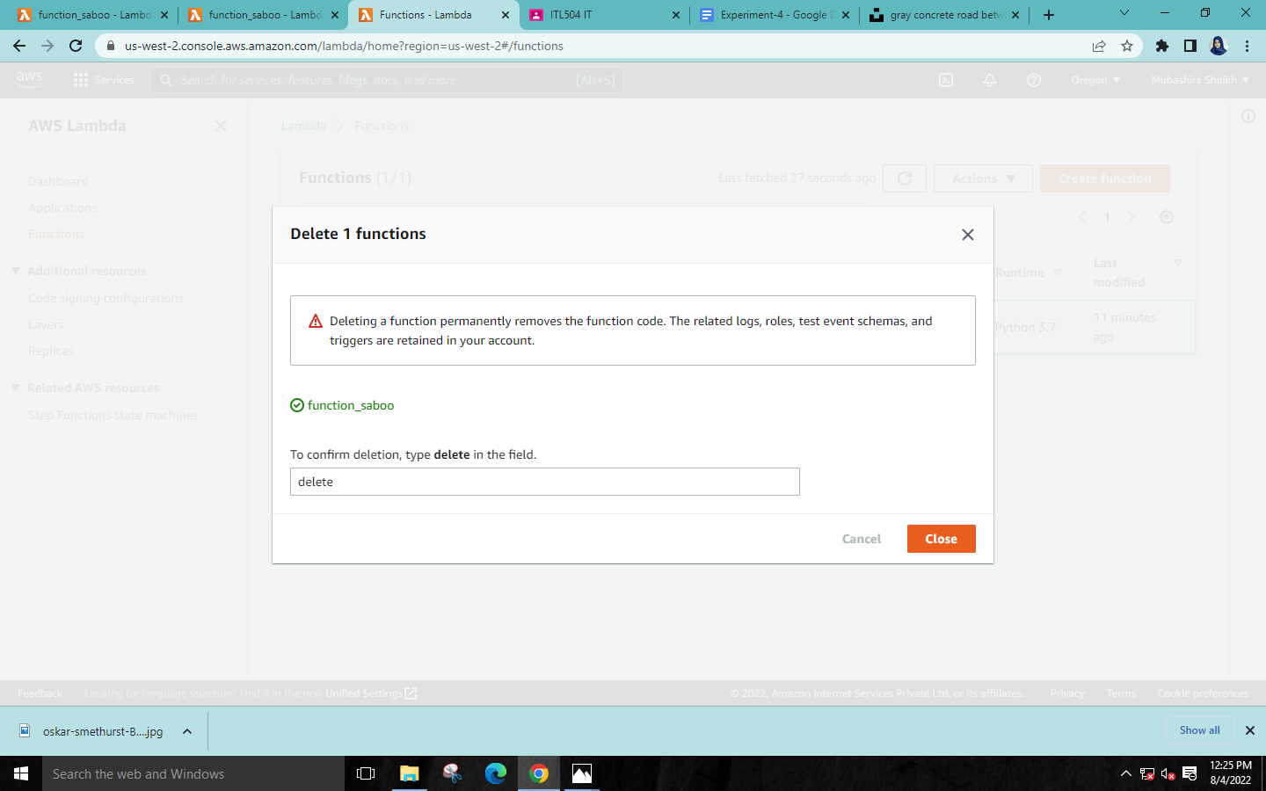

**Step 14:Empty your bucket🡪Delete the bucket.**

